**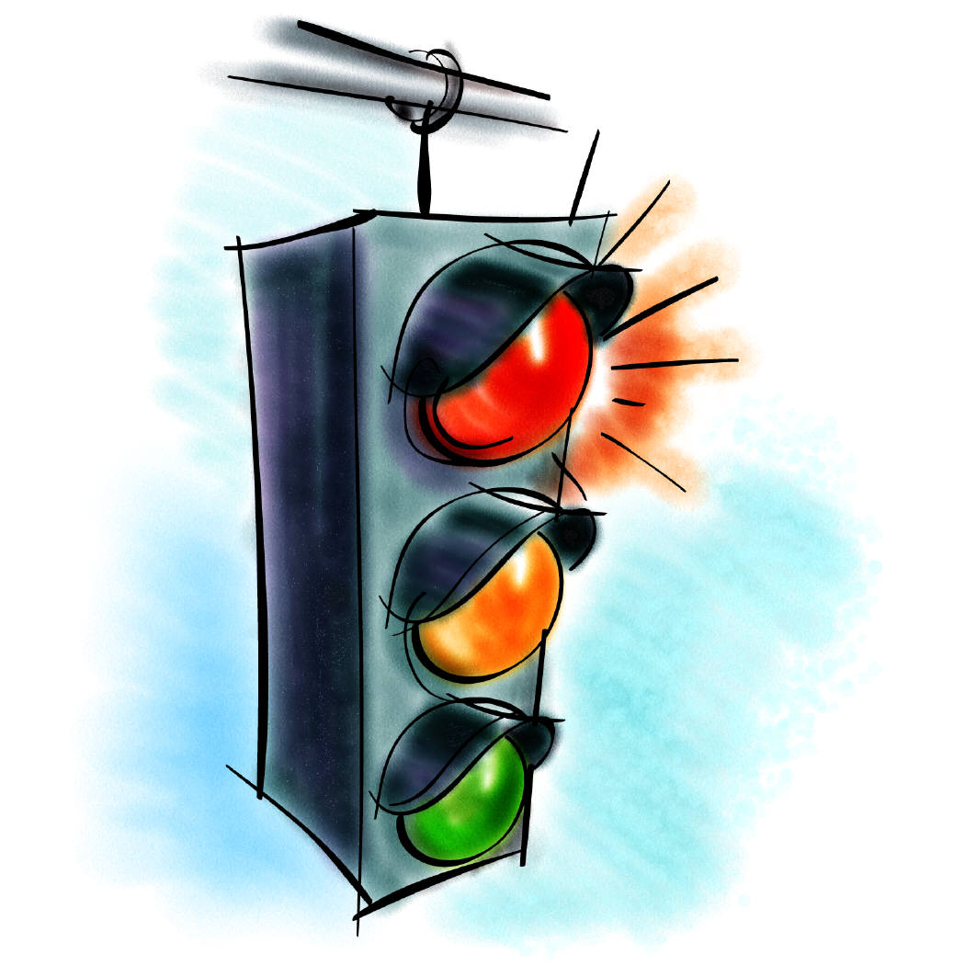 Triple ‘R’ Driving SchoolMCTN00537_0000[1]**

**Rump’s Road Rules**

**Visit us on the web!! 5000 Stream Side Circle**

[**www.rumpsroadrules.com**](http://www.rumpsroadrules.com) **Des Moines, Iowa 50317 *Like us on Facebook!!***

**(319) 470-6975**

**triplerdrivingschool@gmail.com**

***One Great Summer Session to be offered at Keokuk High School!!***

Owned and operated by Mr. Ryan Rump, “Rump’s Road Rules” has become the number one choice for driver education in Southeast Iowa. Students must be at least 14 years of age and **MUST** possess a **valid driver’s permit** prior to the beginning of class. Other pertinent information is as follows:

* The summer driver education session will begin Monday, June 18th and conclude on Tuesday, July 3rd. This session will include classroom hours each weekday June 18th through July 3rd (no weekend classroom times) for three hours (8:00-11:00am). All classroom sessions will be conducted at Keokuk High School.

**\*\*There are 36 class hours that are offered during this session. Students may miss two classes and still be eligible for a certificate of completion. Students missing more then two classroom times will be subject to additional make up classes or may have to take the course again at another time.**

* Driving times (6 hours per student) for this session will be arranged by the instructors on the first day of class. **All efforts will be made to accommodate your busy schedule.**
* The cost of the course will be $340.00. A $170.00 deposit is required with registration. Keokuk CSD students who are eligible for free/reduced lunches are also eligible for free/reduced driver education and should indicate that on the bottom of the form you turn in. Deposits are refundable if notification is given ten days prior to the start of driver’s education. Refunds of any kind **will not be issued** once driver’s education has initiated. The balance of tuition will be collected on the first day of class (**please plan accordingly**). Please make checks payable to **Triple R Driving School L.L.C.** Certificates of completion will not be issued until all financial obligations have been fulfilled.
* Keokuk CSD students can drop off their registration form and deposit to the Keokuk High School office (see Mrs. Messer), or mail the registration and deposit to the above address. Non Keokuk CSD students can mail the registration and deposit to the above address.
* Mr. Matt McGhghy and Mr. Mike Davis will be the classroom and in-car instructor for this session.
* **Confirmation of enrollment will be sent via text message approximately one week before the first day of class.**

**PLEASE SEE THE BACK OF THIS REGISTRATION FORM FOR OPERATING AGREEMENT.**

\*Please submit the following registration and deposit to the above address or return to the office at the high school. **Please retain the top portion of this form for your records.**

**---------------------------------------------------------------------------------------------------------------------------------**

**student:**

**\_\_\_\_\_\_\_\_\_\_\_\_\_\_\_\_\_\_\_\_\_\_\_\_\_ parent:\_\_\_\_\_\_\_\_\_\_\_\_\_\_\_\_\_\_\_\_ \_\_\_\_\_\_\_\_\_\_\_\_\_\_\_\_\_\_\_\_\_\_\_\_\_**

**Student’s Name (First, Middle, Last) Most Accessible Cell Phone Number Full Address**

**\_\_\_\_\_\_\_\_\_\_\_\_\_\_\_\_\_\_\_\_\_\_\_\_\_\_\_\_\_\_\_\_\_\_\_\_\_\_\_\_\_**

**Parents email address (one you check regularly)**

**Operating Agreement for Triple ‘R’ Driving School**

It is the intent of the Triple R Driving School and affiliates of the company to provide instruction and experience to students of all ages in driver education. Instructors of Triple R Driving School are certified teachers in the state of Iowa. The format of the school may vary depending on the time of year (spring, summer, fall, etc.), although instructional content will remain the same.

***Iowa State requirements will be met or exceeded:***

1. Length of the day in the classroom may not exceed 180 minutes.
2. Students will receive at minimum 30 hours of classroom instruction and 6 hours of behind-the wheel training.
3. Students will receive 240 minutes of substance abuse education.
4. Students will receive a minimum of 20 minutes of railroad crossing safety.
5. Students will be provided instruction relating to the organ donation under the Uniform Anatomical Gift Act.
6. The minimum number of times a student will drive in a duel control automobile during the entire course without simulation or range is 12 (30 min sessions) or 6 (one hour sessions).
7. A maximum of 360 minutes of range instruction may be substituted for behind-the-wheel instruction.
8. All driver education instructors, with the exception of behind-the-wheel instructors, must hold a valid Iowa secondary teaching license and the Driver Education endorsement.

**In the unfortunate event of an accident/collision with a student behind the wheel, Triple ‘R’ will ask that the student or family of the student cover half of the deductible for collision repairs ($500.00 deductible for collision insurance; $250.00 responsibility to student or student’s family).**

It is our intent that all students will complete the course at program’s end. However, students with excessive absences, deficient driving abilities or disruptive behavior (as judged by the instructor) may be dismissed from the program or be required to obtain more driving experience before being issued a certificate of completion. Additional driving experience may be obtained with the instructor or other persons meeting state requirements as at the discretion of the instructor. Additional driving with the instructor will be $40.00 per hour.

Upon completion of the course, students will be awarded a certificate of completion. The certificate will allow them eligibility for an intermediate driver’s license under the Graduated License System of the state of Iowa, and also allow them eligibility for a school permit (if eligibility criteria are met). All other Graduated License requirements must be met (see graduated license information from the Department of Transportation). **Lost certificates of completion can be duplicated with a $40.00 fee**.

Any student not showing up for their scheduled drive during the course of driver education will be subject to a $40.00 fee.

\*\* Upon completion of the course, Triple R Driving School, Rump’s Road Rules LLC is not responsible for any action of students.

Description: MMj02867940000[1]